Tuffnell, Glenn (from linked In)
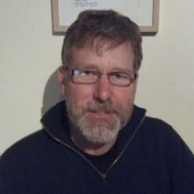
Director at Dieback Treatment Services 2003 – .
I manage a small team of Phytophthora dieback treatment technicians operating in a range of diverse situations throughout the south west of Western Australia. We also map Phytophthora dieback impact and facilitate dieback workshops.

Disease Interpreter CALM February 1991 – March 1993.

